Minister of the Interior visits Headquarters

eu-LISA's responsibilities in implementing the new architecture for EU IT systems for borders, security and justice were the priority topics of talks held today between Executive Director Krum Garkov and Estonian Minister of the Interior Mart Helme in Tallinn.

At the meeting, in the in the Agency's Headquarters, the Executive Director of eu-LISA and the Estonian Minister of the Interior discussed ongoing activities related to the development of new and existing large-scale IT systems and the impact the systems, namely Eurodac, SIS, VIS, EES, ETIAS and ECRIS-TCN, will have on European internal security as a whole.

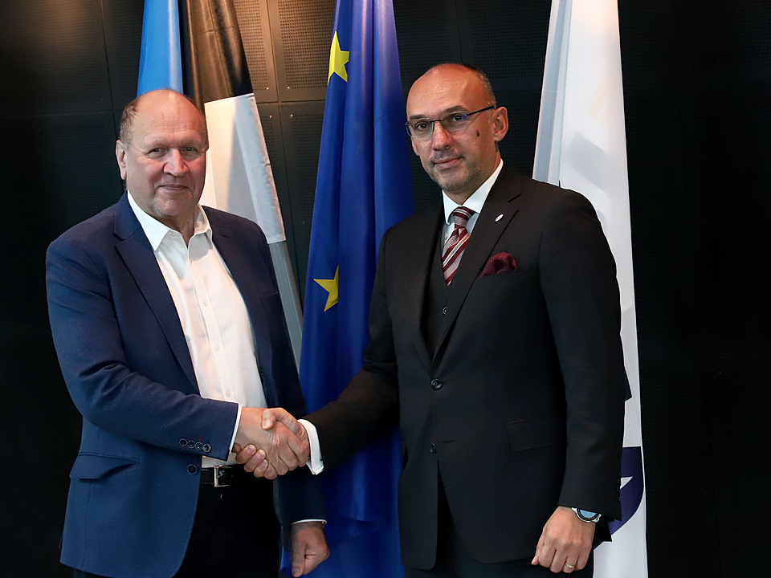

Krum Garkov elaborated on the plans for a new architecture to accommodate Europe's largest IT systems in the JHA domain. He explained that the foreseen improvements, coupled with Interoperability between the systems themselves, will be a real game changer and place European border management at the forefront of the digital era. Mr Garkov emphasised that the entire process is a joint action, which can only be successful if all the Member States commit to it.  He recognised the dedication with which Estonia always addresses innovative solutions and provides a model for many others to follow. Mr Garkov gave Minister Helme an overview of the Agency's recent restructuring and illustrated the expected benefits to both eu-LISA's core business and the overall management of resources.

Topics addressed also included the upcoming eu-LISA Annual Conference, to be held in Tallinn on the 16th October, at which Minister Helme will give a keynote speech and the Industry Roundtable the following day.

During his visit Minister Helme stated "*eu-LISA´s headquarters being in Tallinn is of major significance for Estonia as a country with a strong IT-background. Furthermore, the Agency is currently executing one of the biggest and most ambitious projects in the field of EU internal security – the interoperability of European Union information systems for police forces as well as border and migration management. Estonia has emphasized for a long time the importance of breaking the silos between the separate information systems, with an aim to ensure more efficient crime fighting, for instance identity fraud. Today, thanks to eu-LISA and other contributors, we are closer to that goal than ever before.*"